**DATA COMMUNICATION**

**LAB 6: NODE MCU – SERVER MODE (AP MODE)**

# Introduction to Working Mode in ESP8266 Series

The ESP8266 or almost every Wifi modules usually have three working modes: Station, AP (Access Point) and Dual mode. The Station mode is similar to the computers, cell phones or tables while the AP mode is playing a role of the routers in our network. In a combination, the dual mode allows the Wifi module to work in both Station and AP mode. The ESP8266, ESP8285 and ESP32 module fully support three modes mentioned above.

A Web [server](https://whatis.techtarget.com/definition/server) is a program that uses [HTTP](https://searchwindevelopment.techtarget.com/definition/HTTP) (Hypertext Transfer Protocol) to serve the files that form Web pages to users, in response to their requests, which are forwarded by their computers' HTTP clients. Dedicated computers and appliances may be referred to as Web servers as well.

# Getting Started with Examples

Download an example project from this link <https://www.dropbox.com/s/9od6hox6cn7073f/LED_Webserver.ino?dl=0>

Open the LED_Webserver.ino then change the wifi ssid and password according to your wifi network.

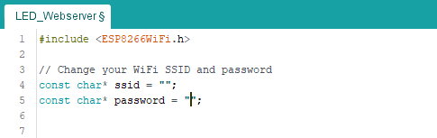

Figure : Provide the SSID and Password of the wifi

You can also change the LED pin in case you don’t want to use the LED on board (GPIO 2)

Then upload the program to your NodeMCU and open the Serial console.

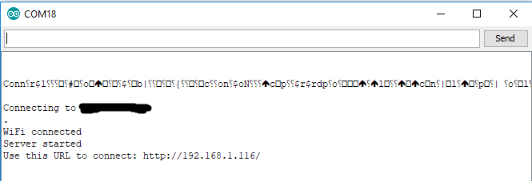

Figure : Server is running at a local address

Open your browser and enter the URL (local ip address) displayed in the Serial console, you will see the following website (see Figure 1)

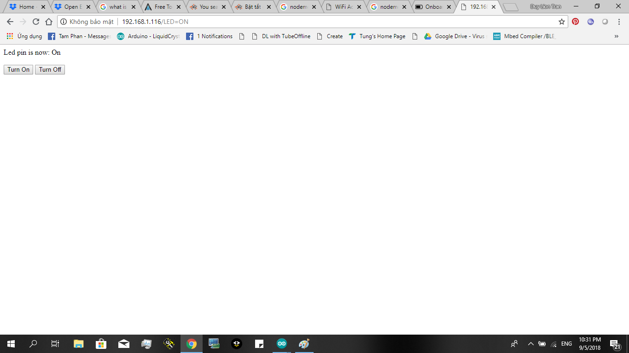

Figure 3: Example of LED demo

If you press the “Turn On” button, the LED on the NodeMCU will turn on, and if you press “Turn Off”, the LED will turn off. You can also look at the following URL for a better web interface: [https://hocarm.org/dieu-khien-den-hoc- qua-website-voi-esp8266/](https://hocarm.org/dieu-khien-den-hoc-%09qua-website-voi-esp8266/)

# Exercise

1. Write a program that update the sensor values (or any kind of value you want) to the NodeMCU webserver. You can use the following URLs for references: <https://www.teachmemicro.com/display-sensor-data-nodemcu-web-server/> and <https://circuits4you.com/2018/02/04/esp8266-ajax-update-part-of-web-page-without-refreshing/>

# Extra Exercise

1. Write a program that connect the NodeMCU to an online server (using MQTT or POST/GET request e.g) then display the current time to your webserver (it is expected that you display time of various countries). You can get the time from this URL: <http://www.iforce2d.net/test.php>

Note: please do all the above exercises with all your best, you will find that you have learned a lot. There is also a very helpful library for you: <https://github.com/tzapu/WiFiManager> This library has a very good ESP8266 webserver and this webserver works in AP (access point) mode.

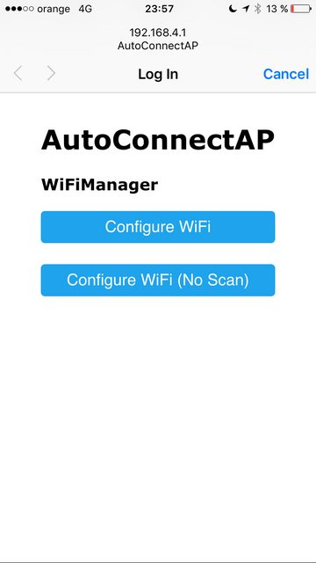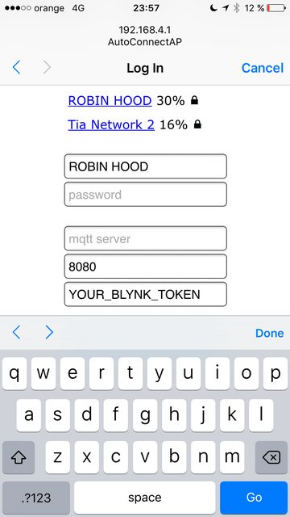

A very good project for your reference, please read and use it carefully with responsibility: <https://github.com/spacehuhn/esp8266_deauther> Below is the web interface of the project:

